1.0 | Pairing True Wireless Stereo via JBL Pro Connect app |  | 0-XXX-00
True Wireless Stereo (TWS) via the JBL Pro Connect app enables wireless operation of multiple speakers while streaming Bluetooth Audio, and is currently available for the EON One MKII, PRX One, EON700 Series’, and EON One Compact speakers.
Minimum firmware versions required for TWS via JBL Pro Connect:
- EON One MKII: 5.2.4.0
- PRX One: 5.3.2.0
- EON700 Series’: 6.2.1.0
- EON One Compact: 6.2.0.0
Note: BT Audio must be connected only to the “Host” speaker for expected functionality.

Procedure
- Begin by opening the JBL Pro Connect app on your mobile or tablet device. Navigate to the "Add Speakers" menu, where you should find your speakers listed under "Available Loudspeakers."

- Prior to tapping 'Connect,' access the LCD at the back of the speaker. Use the Master/Menu knob to enter the Settings menu and select "BT Control Pairing." A pop-up on the LCD will indicate you have 30 seconds to pair your speaker with the app.
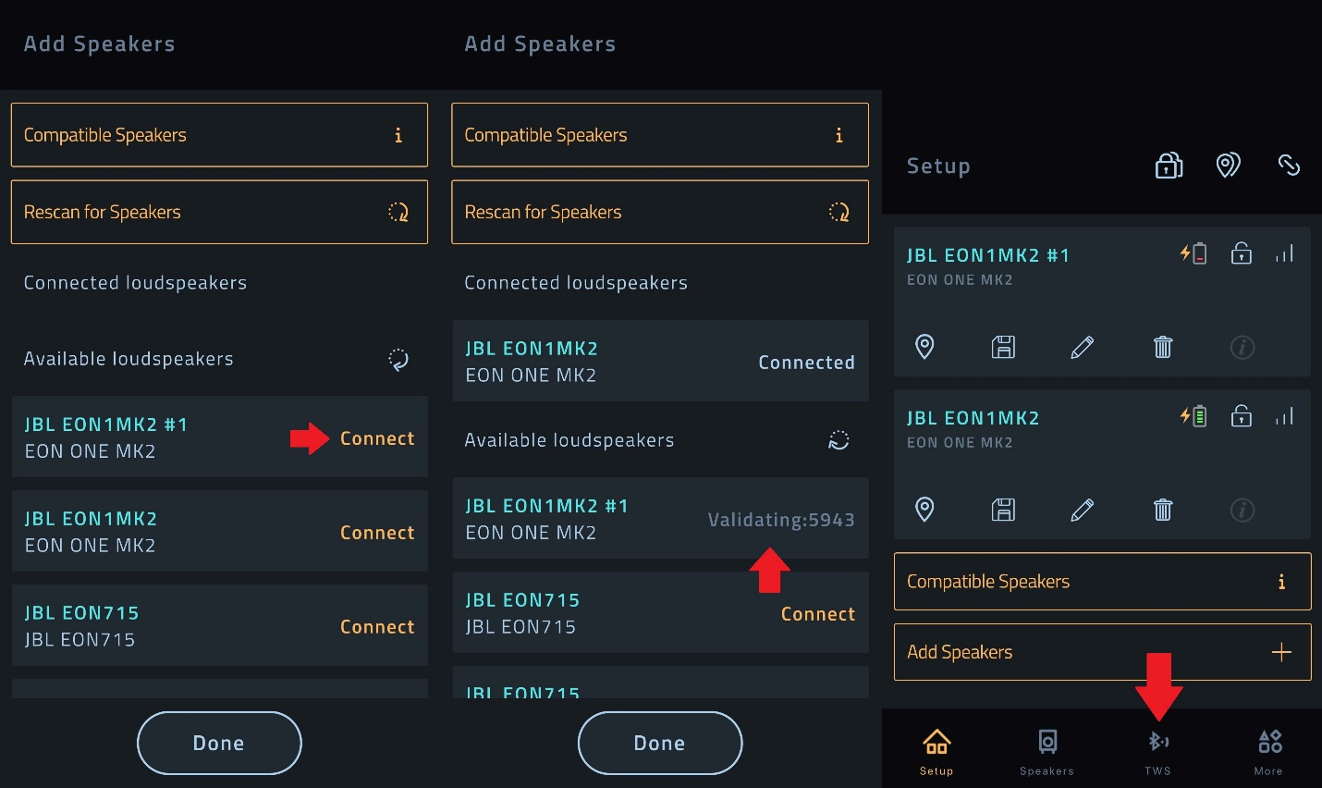
- Tap 'Connect.' (Note: EON One Compact users can skip the next step.)

- In the app, when "Validating:XXXX" appears with a 4-digit pin number, use the Master/Menu knob at the back of the speaker to select 'Yes' and confirm the Pin number. Your speaker will now be displayed as 'Connected.' In case of an error, retry the pairing process from step 2.

- Repeat the pairing process for the second speaker.

- Tap "Done" to return to the Setup menu, which will now showcase both of your connected speakers.

- From the Setup menu, select the TWS menu option. Both connected speakers, along with Host and Remote buttons, will be visible. The buttons to the right will remain grayed out until a successful pairing.
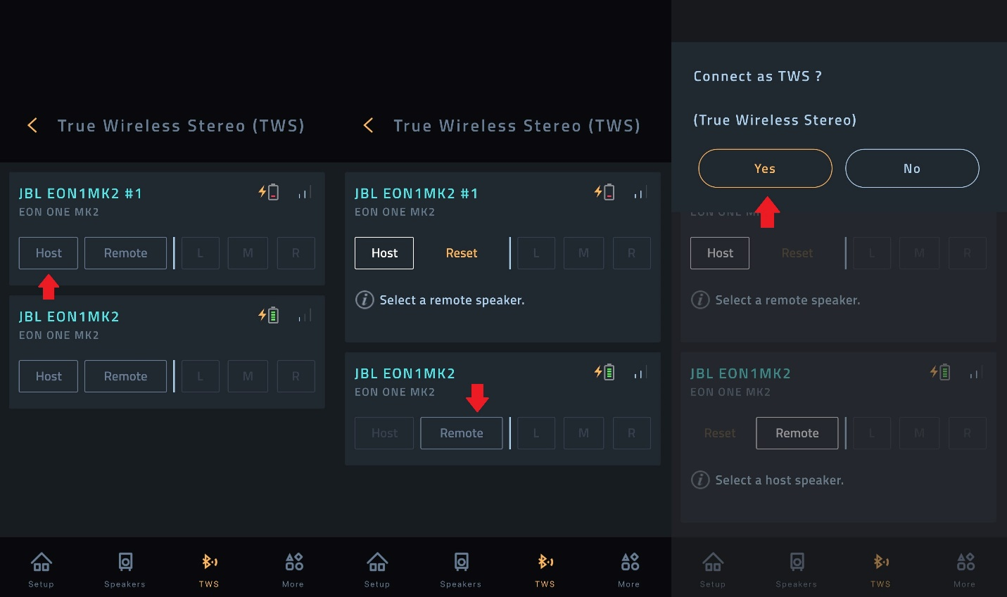
- Assign your Host and Remote speakers.

- A prompt will appear, asking, "Connect as TWS?" Select 'Yes.' This process may take up to 35 seconds. If an error occurs, retry the pairing from step 7.

- Once successfully connected, you will receive a confirmation message and return to the TWS menu. The buttons on the right will now be active, allowing you to select Left, Right, or Mono output for each connected speaker.
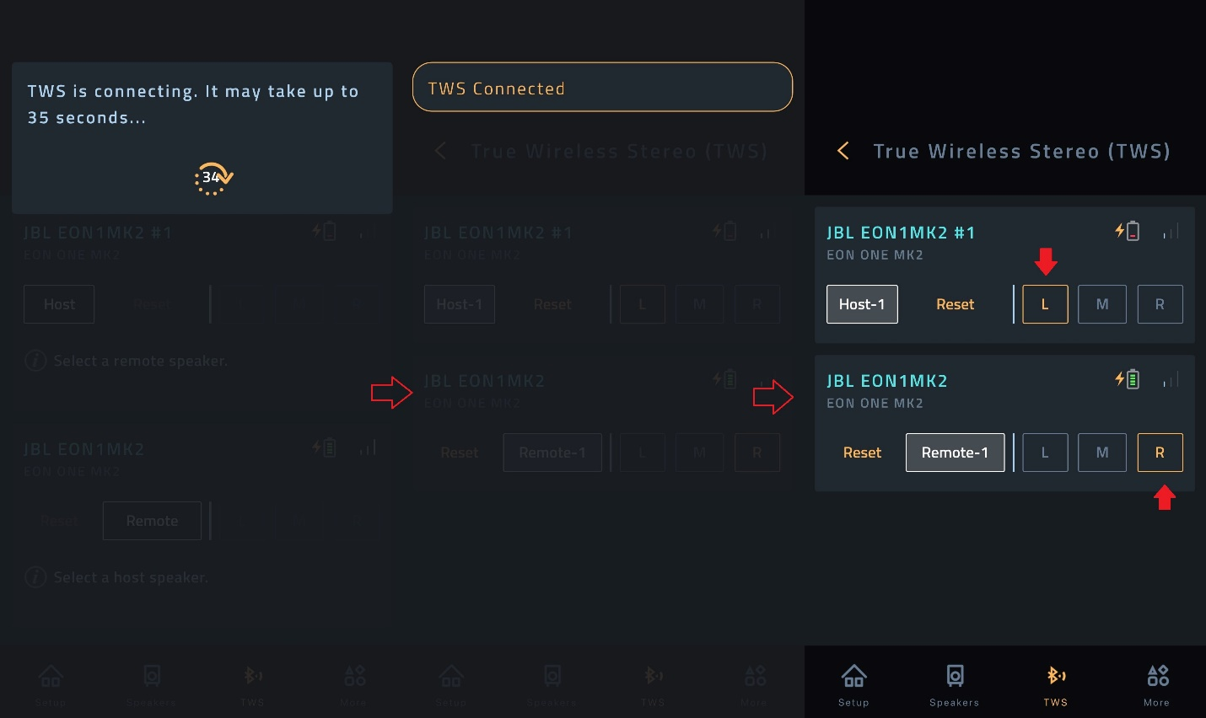

You are now ready to stream BT Audio in True Wireless Stereo!
Tips: Rename speakers using the Pencil icon in the Setup menu to include ‘Host’ and ‘Remote’ to easily ensure BT Audio is connected to the Host speaker.
If experiencing interference, try closing out of the Pro Connect app while BT audio is streaming.

